Python Sets
Sets are unordered collection of data items. They store multiple items in a single variable. Set items are separated by commas and enclosed within curly brackets {}. Sets are unchangeable, meaning you cannot change items of the set once created. Sets do not contain duplicate items.
Example:
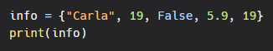
Output:
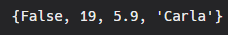
Here we see that the items of set occur in random order and hence they cannot be accessed using index numbers. Also sets do not allow duplicate values.
Quick Quiz: Try to create an empty set. Check using the type() function whether the type of your variable is a set
Accessing set items:
Using a For loop
You can access items of set using a for loop.
Example:
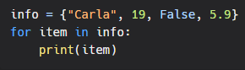
Output:
